**Battle of the Neighborhoods**

**(Delhi Metro Rail Corporation)**

**Introduction: Business Problem**

In this project we will try to find an optimal location for a Cafeteria. Specifically, this report will be targeted to stakeholders interested in opening an **Cafeteria** in **Delhi**, India.

Since there are lots of Cafe's in Delhi we will try to detect **locations that are not already crowded with self serving Cafeteria's**. We are also particularly interested in **all the areas within 500m radius of Metro Stations along Delhi Mtero Rail Corp. network**. We would also prefer locations **as close to Metro Station as possible**, assuming that first two conditions are met.

We will use our data science powers to generate a few most promissing neighborhoods based on this criteria. Advantages of each area will then be clearly expressed so that best possible final location can be chosen by stakeholders.

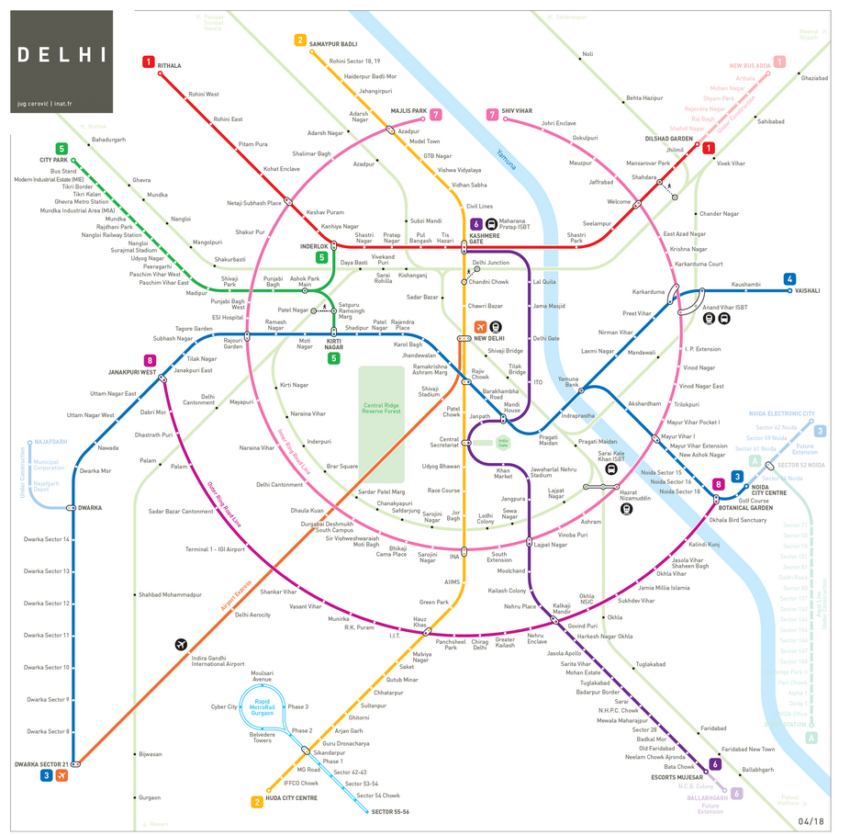

## Data

Based on definition of our problem, factors that will influence our decision are:

* number of metro stations in DMRC network ( included Rapid Metro Stations)
* number of existing Cafe/restaurants in the 500m radius of Metro Station (any type of Self Serving Restaurant/Cafe)
* number of and distance to nearby Cafeteria in the neighborhood, if any
* distance of neighborhood from Metro Stations

We decided to use regularly spaced grid of locations, centered around each Metro Station, to define our neighborhoods.

Following data sources will be needed to extract/generate the required information:

* centers of candidate areas will be generated algorithmically and approximate addresses of centers of those areas will be obtained using **Google Maps API reverse geocoding**
* number of restaurants and their type and location in every neighborhood will be obtained using **Foursquare API**
* coordinate of Berlin center will be obtained using **Google Maps API geocoding** of well known Berlin location (Alexanderplatz)

**Web Scraping using BeautifulSoup for Data Collection**

[Web Scraping](http://en.wikipedia.org/wiki/Web_scraping) (also termed Screen Scraping, Web Data Extraction, Web Harvesting etc.) is a technique employed to extract large amounts of data from websites whereby the data is extracted and saved to a local file in your computer or to a database in table (spreadsheet) format.

Data displayed by most websites can only be viewed using a web browser. They do not offer the functionality to save a copy of this data for personal use. The only option then is to manually copy and paste the data - a very tedious job which can take many hours or sometimes days to complete. [Web Scraping](http://www.webharvy.com) is the technique of automating this process, so that instead of manually copying the data from websites, the [Web Scraping software](http://www.webharvy.com) will perform the same task within a fraction of the time.

**Setting up Target URL**

“ <https://delhimetrorail.info/delhi-metro-stations> “ - DelhiMetroRail website gonna be our Target URL from which we will fetch all the Metro Stations related Data and details of each metro Station.

**Neighborhood Candidates**

Let's create latitude & longitude coordinates for centroids of our candidate neighborhoods. We will create a grid of cells covering our area of interest which is aprox. 500 meters centered around each Metro Station of Delhi Metro.

Let's first find the Unique name of each Metro Station by Web Scraping the Metro Network Data from DMRC website using BeautifulSoup package and further Geo-Coding each using well known address and Google Maps geocoding API.

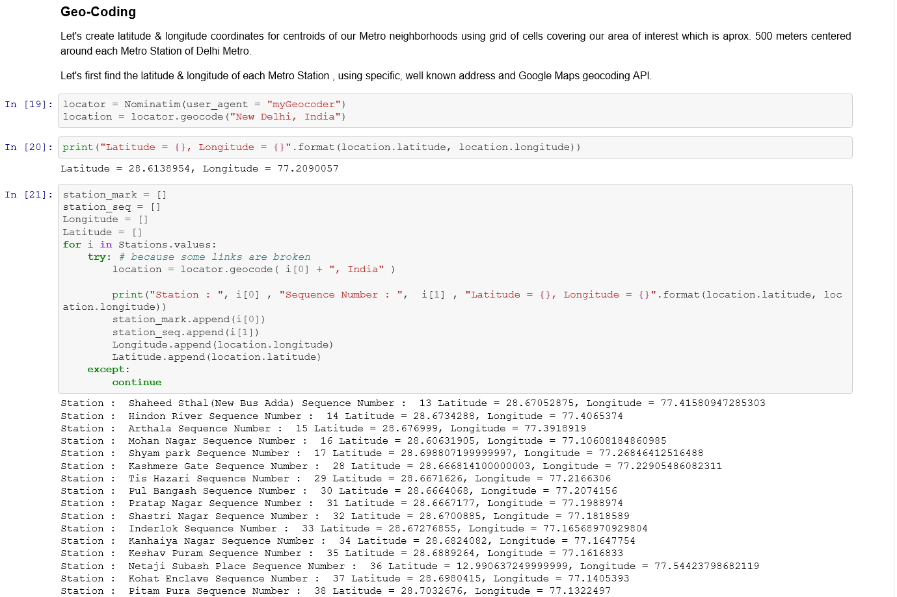

**Methodology**

In this project we will direct our efforts on detecting areas along Delhi Metro Network that have low restaurant density, particularly those with low number of self serving Cafeteria's. We will limit our analysis to area ~500m around each Metro Station in DMRC network.

In first step we have collected the required **data: location and type (category) of every venue within 500m from each Metro Station center** . We have also **identified all the existing Cafeteria's** (according to Foursquare categorization).

Second step in our analysis will be calculation and exploration of '**Cafeteria density**' across different Metro Stations of DMRC network - we will use **folium map visualizations** to identify a few promising areas close to Metro Stations with low number of Cafeteria's in general (*and* no Self Serving Cafeteria in vicinity) and focus our attention on those areas.

In third and final step we will focus on most promising areas and within those create **clusters of locations that meet some basic requirements** established in discussion with stakeholders: we will take into consideration locations with **all the Venues/Restaurants in radius of 500 meters**, and we want locations **without much Cafe's in radius of 500 meters**. We will present map of all such locations but also create clusters (using **k-means clustering**) of those locations to identify general zones / neighborhoods / addresses which should be a starting point for final 'street level' exploration and search for optimal venue location by stakeholders.

**Map Visualization using Folium**

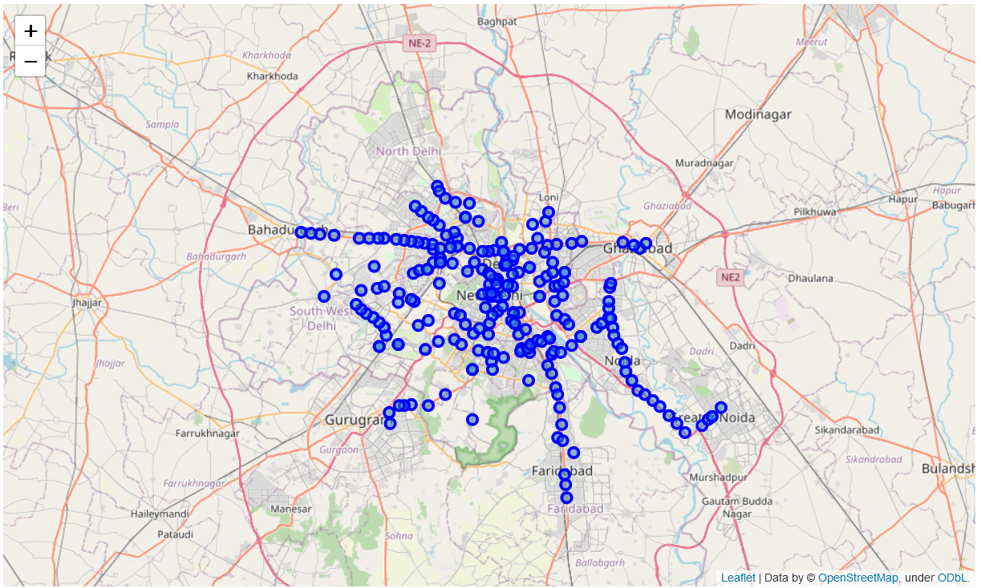

**Foursquare Venues Collection**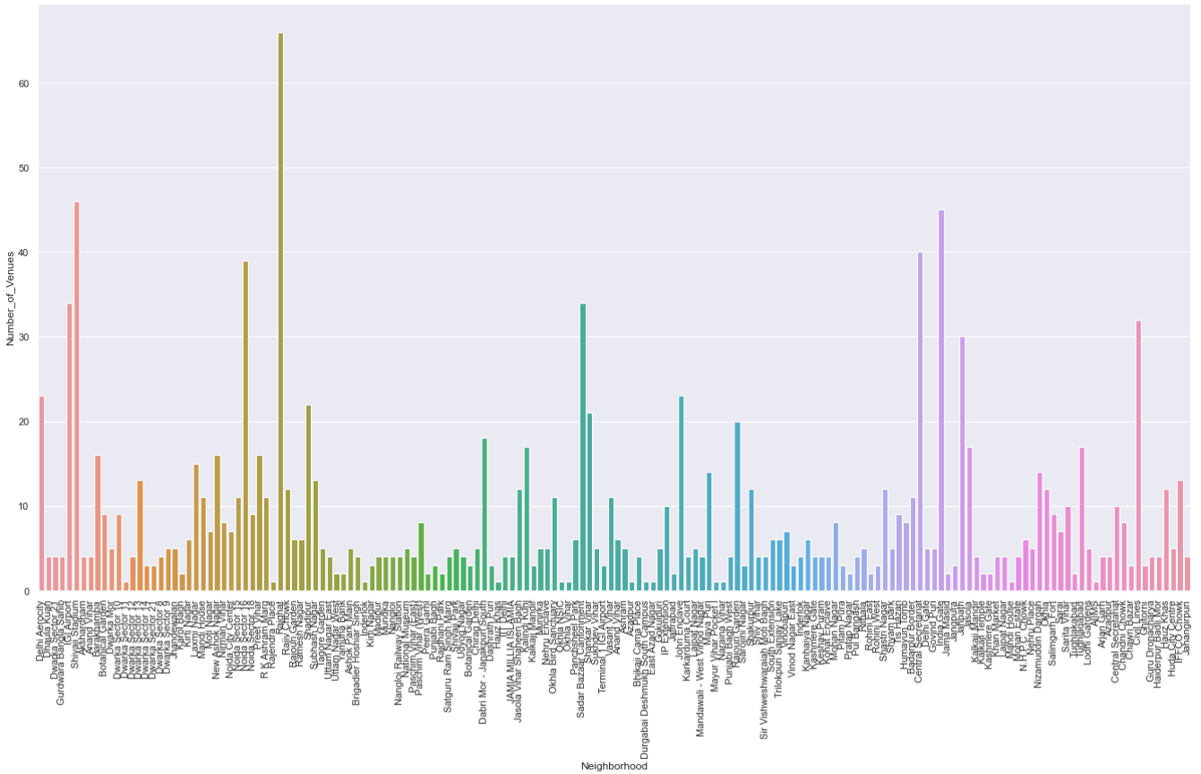

**Neighbourhood Venues Data Collection**

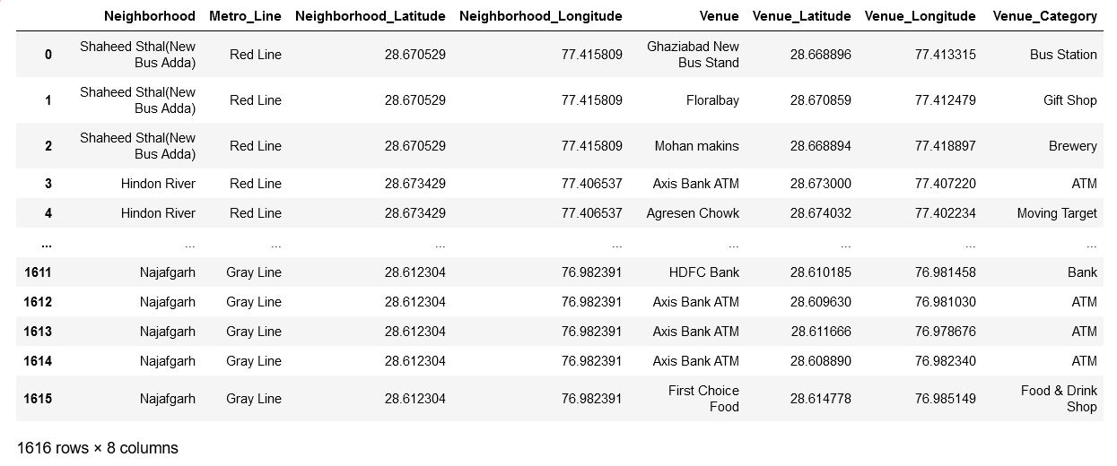

**Clustering**

**Clustering** is one of the most common exploratory data analysis technique used to get an intuition about the structure of the data. It can be defined as the task of identifying subgroups in the data such that data points in the same subgroup (cluster) are very similar while data points in different clusters are very different. In other words, we try to find homogeneous subgroups within the data such that data points in each cluster are as similar as possible according to a similarity measure such as euclidean-based distance or correlation-based distance. The decision of which similarity measure to use is application-specific.

**Neighbourhood’s Most Common Venues**

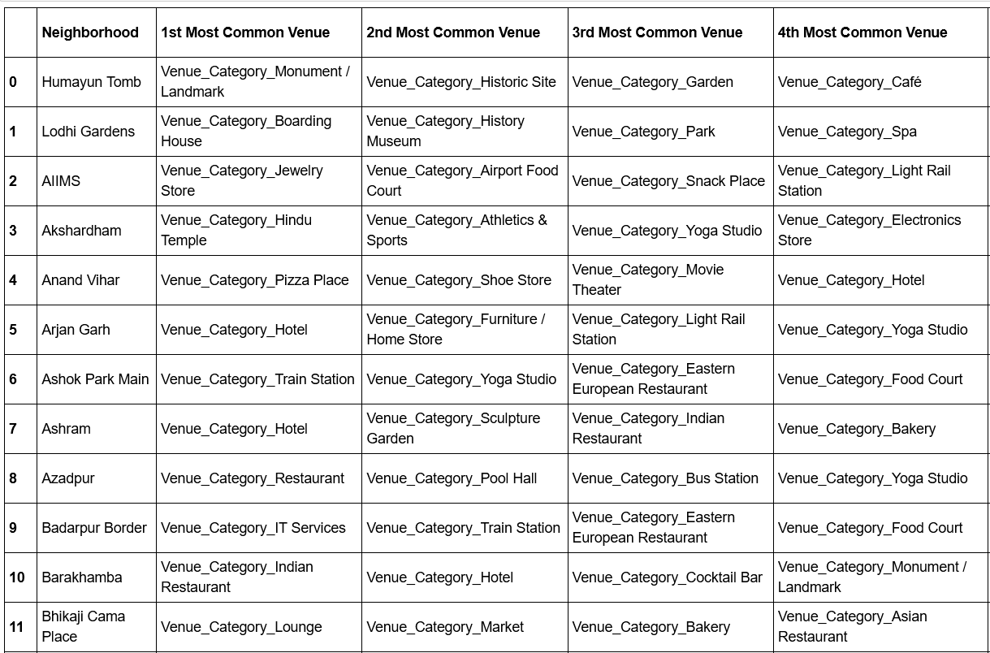

**Clustering using K-Means**

Clustering analysis can be done on the basis of features where we try to find subgroups of samples based on features or on the basis of samples where we try to find subgroups of features based on samples. We’ll cover here clustering based on features. Clustering is used in market segmentation; where we try to find customers that are similar to each other whether in terms of behaviors or attributes, image segmentation/compression; where we try to group similar regions together, document clustering based on topics, etc.

Unlike supervised learning, clustering is considered an unsupervised learning method since we don’t have the ground truth to compare the output of the clustering algorithm to the true labels to evaluate its performance. We only want to try to investigate the structure of the data by grouping the data points into distinct subgroups.

**K-means Algorithm**

**Kmeans** algorithm is an iterative algorithm that tries to partition the dataset into *K*pre-defined distinct non-overlapping subgroups (clusters) where each data point belongs to **only one group**. It tries to make the intra-cluster data points as similar as possible while also keeping the clusters as different (far) as possible. It assigns data points to a cluster such that the sum of the squared distance between the data points and the cluster’s centroid (arithmetic mean of all the data points that belong to that cluster) is at the minimum. The less variation we have within clusters, the more homogeneous (similar) the data points are within the same cluster.

The way kmeans algorithm works is as follows:

1. Specify number of clusters *K*.
2. Initialize centroids by first shuffling the dataset and then randomly selecting *K* data points for the centroids without replacement.
3. Keep iterating until there is no change to the centroids. i.e assignment of data points to clusters isn’t changing.

* Compute the sum of the squared distance between data points and all centroids.
* Assign each data point to the closest cluster (centroid).
* Compute the centroids for the clusters by taking the average of the all data points that belong to each cluster.

The approach kmeans follows to solve the problem is called **Expectation-Maximization**. The E-step is assigning the data points to the closest cluster.

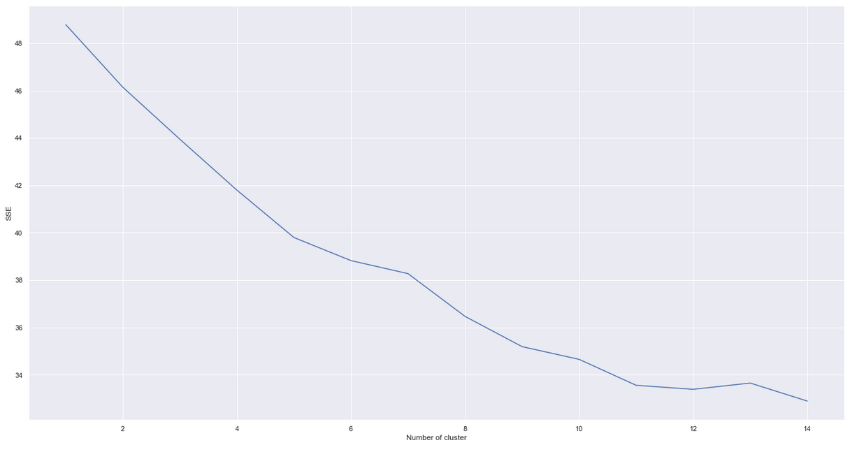

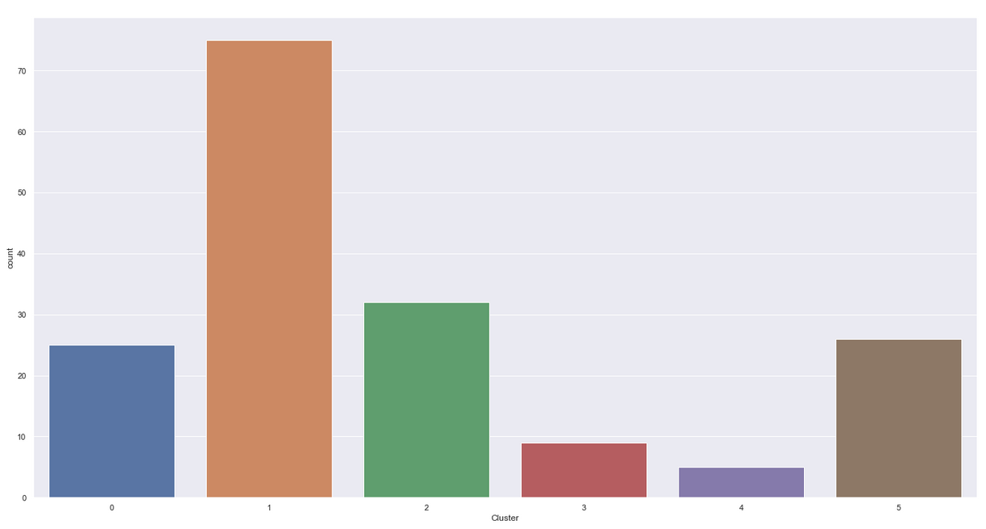

**Cluster Visualization**

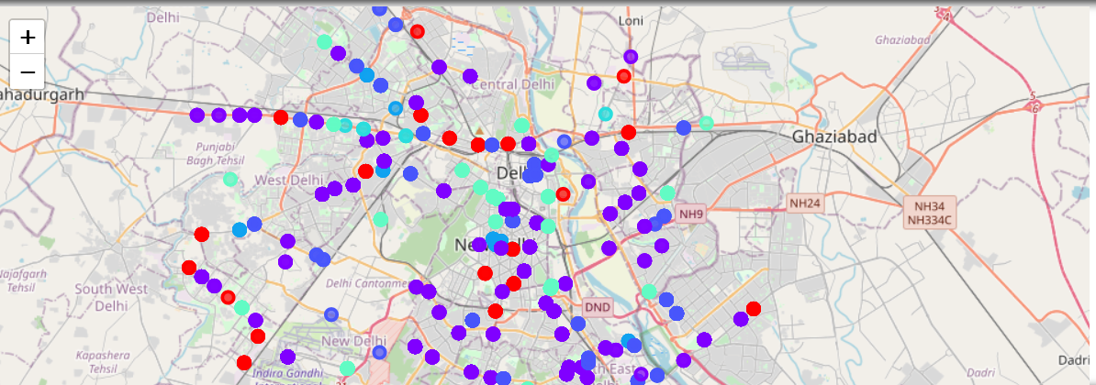

**Cluster-1 Interpretation**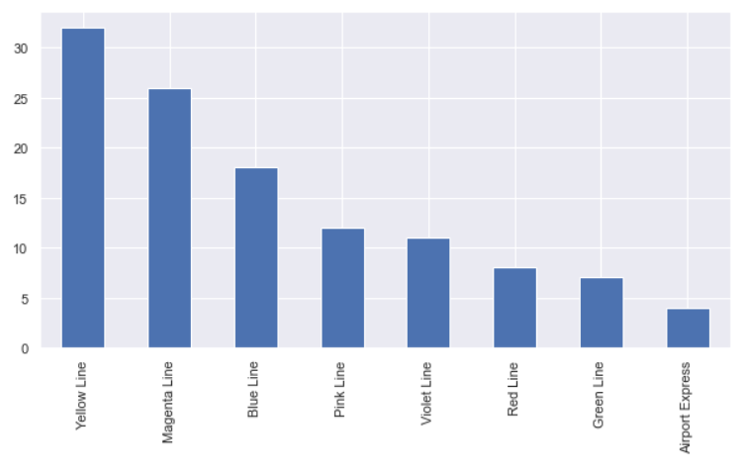

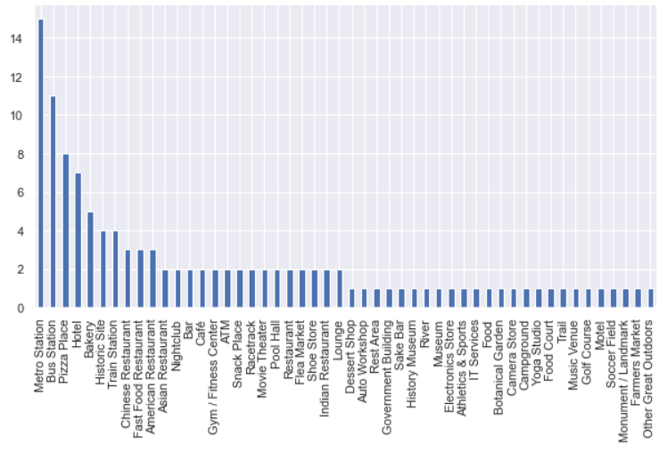

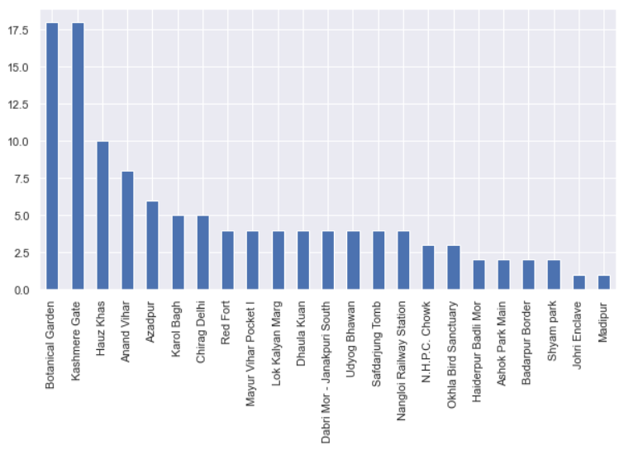

Locations Suggested from Cluster 1

(similar Analysis for each Cluster)

**Results and Discussion**

* Our analysis shows that although there is a great number of restaurants/Cafe's in Delhi (~1800 in our initial area of interest which was whole DMRC network), there are pockets of low restaurant density fairly close to some Metro Stations. Highest concentration of Cafeteria's was detec ted in Cluster 0 and 2 along Blue , Yellow ,Violet and Magenta Line of DMRC, so we focused our attention to areas where Cafe intensity is comparatively low. Another Metro Line was identified as potentially interesting (Magenta_Line and Green Line), but our attention was focused on Cluster 1 which offer a combination of popularity among travellers, closeness to city center, strong socio-economic dynamics *and* a number of pockets of low Cafe density.
* After directing our attention to this more narrow area of interest (covering cluster 1) we first created a dense grid of location candidates ; those locations are identified as Tagore Garden,India Gate,Kalkaji Mandir,AIIMS and Laxmi Nagar. These location candidates are our zones of interest which contain lowest number of existing Cafe's. Addresses of centers of those zones were also generated using reverse geocoding to be used as markers/starting points for more detailed local analysis based on other factors.
* Result of all this is 6 zones containing largest number of potential new Cafe locations based on number of and distance to existing venues - both Self Serving Restaurants in general and Cafeteria particularly. This, of course, does not imply that those zones are actually optimal locations for a new Cafeteria! Purpose of this analysis was to only provide info on areas close to Metro Stations but not crowded with existing Self Serving Restaurants (particularly Cafe) - it is entirely possible that there is a very good reason for small number of restaurants in any of those areas, reasons which would make them unsuitable for a new restaurant regardless of lack of competition in the area. Recommended zones should therefore be considered only as a starting point for more detailed analysis which could eventually result in location which has not only no nearby competition but also other factors taken into account and all other relevant conditions met.

**Conclusion**

Purpose of this project was to identify Delhi areas close to DMRC Metro Stations with low number of Self Serving - Restaurants (particularly Cafeteria) in order to aid stakeholders in narrowing down the search for optimal location for a new Cafeteria. By calculating restaurant density distribution from Foursquare data we have first identified general boroughs that justify further analysis (Cluster 1 and 2), and then generated extensive collection of locations which satisfy some basic requirements regarding existing nearby restaurants. Clustering of those locations was then performed in order to create major zones of interest (containing greatest number of potential locations) and addresses of those zone centers were created to be used as starting points for final exploration by stakeholders.

Final decission on optimal Cafe location will be made by stakeholders based on specific characteristics of neighborhoods and locations in every recommended zone, taking into consideration additional factors like attractiveness of each location (proximity to park or water), levels of noise / proximity to major roads, real estate availability, prices, social and economic dynamics of every neighborhood etc.